HemoSim NEW edit doc - I13
HOW TO USE: edit the wording directly (Track Changes if you like). For layout or a figure (size, position, wrong/missing image) write a short instruction in [brackets] right where it applies. Send it back and I apply the wording to the page and the layout notes to the styling, then regenerate. This is a content+notes doc, so it will not look exactly like the web page.

ISSUES FLAGGED FOR THIS MODULE (5) -PAST MODULE-
These were found while the module was built and are not part of the prose. SOURCE means the defect is in a deck, a Notion page or the source index and has to be fixed there too. DECISION means it needs your call before the page is final. NOTE is for information. Answer them in [brackets] like any other instruction.
[DECISION: The curriculum states two different PPV thresholds. Deck summary slide 203 gives 12.5 percent, ANDROMEDA-SHOCK-2 uses 13 percent. The page publishes the provenance of both rather than picking one. Decide whether the curriculum should state a single number.]
[NOTE: The threshold published is 13 percent from Michard 2000, PMID 10903232. The meta-analysis is Marik 2009, PMID 19602972, 29 studies, 685 patients, PPV AUC 0.94, threshold 12.5 plus or minus 1.6 percent. Messina 2023 is published as counterweight: 59 studies, 2,947 patients, AUC 0.77, threshold 10.8 percent. The grey zone is Cannesson 2011 and Biais 2014.]
[NOTE: No human study of PPV validity in intra-abdominal hypertension exists. Only porcine data is given, Renner and Jacques, and the page states that human thresholds are unestablished.]
[SOURCE: INDEX.md section 4 lists slide177 and slide180 as two figures for this module. They are the same image.]
[NOTE: The deck's slide 183 says "about 12.5 percent variation for both indices". Marik 2009 gives 12.5 percent for PPV, 11.6 for SVV, and no SPV threshold. The page follows the paper.]

Evaluating respiratory variation in pressure and flow.
Module I12 followed a positive-pressure breath through the circulation. Inspiration changes the pressure surrounding the heart and great vessels, alters systemic venous return and right ventricular loading, and produces a respiratory change in right ventricular output. After transit through the pulmonary circulation, that change reaches the left ventricle and appears as a cyclic change in left ventricular stroke volume. I13 starts there.
Positive-pressure ventilation is therefore more than a way of moving gas. In a passive patient it is a cardiovascular provocation repeated several times every minute. Each breath perturbs the circulation, and the size of the resulting change in stroke volume contains information about where the cardiopulmonary system is operating on its function curve. The arterial pressure waveform gives us one way to observe that response. A stroke-volume monitor gives us another.
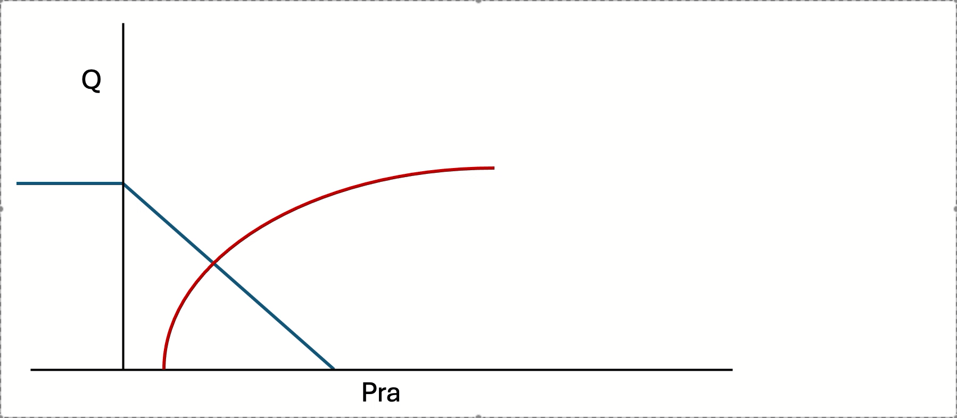
The important distinction is that these are responses to a provocation, not measurements of blood volume. A large respiratory variation does not tell us how much blood the patient has. It tells us that, under the current conditions, cardiac output changes substantially when preload and right ventricular loading are cyclically perturbed.

Positive-pressure breathing as a repeated hemodynamic perturbation. Each breath transiently changes the conditions governing venous return and cardiac output, moving the operating point of the circulation and producing a cyclic change in flow. PPV and SVV are different ways of observing the downstream consequences of that repeated perturbation.
From the ventilator to the arterial trace
Reading preload responsiveness from an arterial waveform is an inference built from a chain of physiologic events. The ventilator first delivers a tidal volume. Some fraction of the pressure required to deliver that breath reaches the pleural space. The resulting change in intrathoracic pressure alters venous return, right ventricular filling and right ventricular afterload. The change in right ventricular output then travels through the pulmonary circulation and changes left ventricular filling a few beats later. Left ventricular stroke volume consequently varies over the respiratory cycle. Finally, that variation in stroke volume is transformed by the arterial system into a variation in pressure and recorded through the catheter-transducer system.
This chain matters because every requirement for PPV and SVV validity belongs somewhere along it. Spontaneous effort changes the provocation. Lung and chest-wall mechanics change pressure transmission. Arrhythmia changes stroke volume independently of respiration. A high respiratory rate can prevent the delayed right-to-left signal from being fully expressed. Right ventricular failure creates respiratory stroke-volume variation for an afterload reason rather than a preload reason. The arterial system determines how much pressure results from a given stroke volume. Finally, damping, resonance, sampling site and pulse-contour algorithms determine whether what appears on the monitor faithfully represents what happened in the patient.
The usual checklist of “contraindications to PPV” is therefore not really a list. It is this causal chain read backwards. The advantage of learning the chain is that it also tells you why a particular condition creates a false positive, a false negative, or a completely uninterpretable signal. The current module already contains this broken-link concept, and it is worth preserving as its organizing physiology.

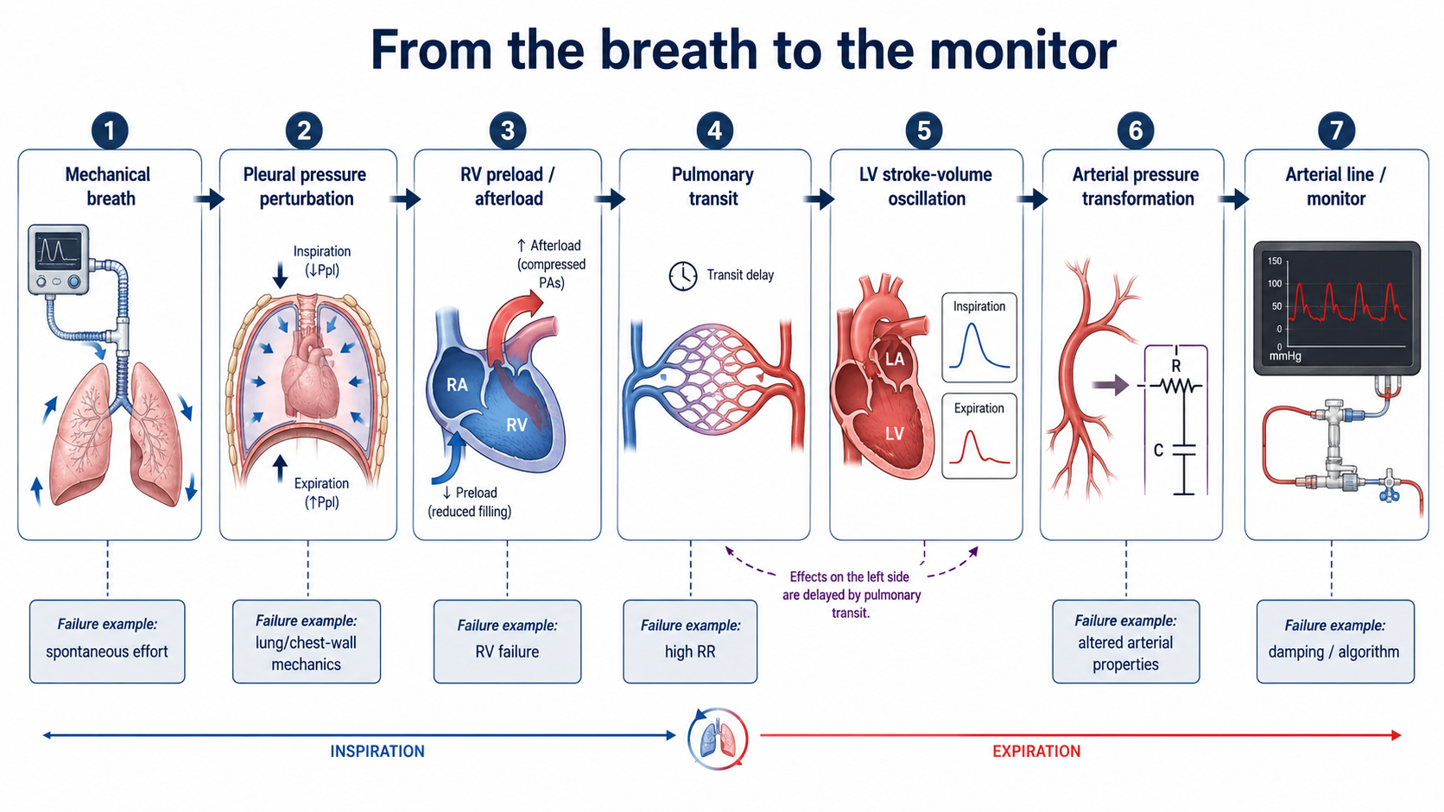

The last two links deserve particular attention. Module I4 established that the arterial system does not passively display stroke volume. It transforms an ejected volume into a pressure waveform. As a useful first approximation,
PP≈ SV/C_{art​​}
where PP is pulse pressure, SV is stroke volume and C_{art} is total arterial compliance. Over a few beats, if arterial properties and the pattern of ventricular ejection remain reasonably stable, a larger stroke volume generally produces a larger pulse pressure and respiratory changes in pulse pressure therefore track respiratory changes in stroke volume. This is the basic licence for reading a flow-related signal from a pressure trace.
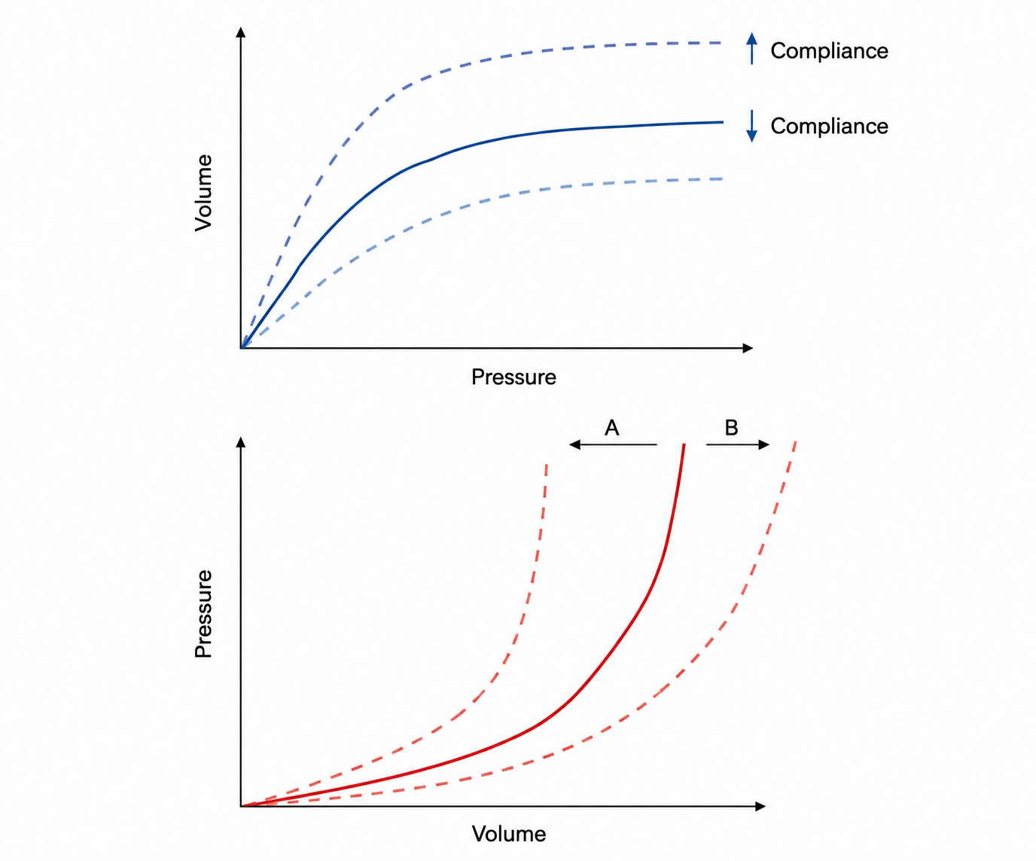
Arterial compliance determines how a given change in arterial volume is translated into pressure, so the same stroke volume can generate different pulse pressures depending on the pressure–volume properties of the arterial tree.

But it is only a first approximation. The pressure created by a given stroke volume also depends on the properties of the arterial system into which that volume is ejected: compliance, characteristic impedance, peripheral runoff, wave transmission and reflection, the site where the pressure is measured, and the timing and acceleration of ventricular ejection. That distinction will become important later in this module, because it explains why pulse pressure variation and stroke volume variation are closely related without being identical, and why their ratio can contain additional information.

Systolic pressure variation: where the signal was first found
The original dynamic arterial index was systolic pressure variation. Perel and colleagues defined SPV as the difference between the maximum and minimum systolic arterial pressures during positive-pressure ventilation and divided it against a systolic reference pressure measured during a brief end-expiratory apnea.
$$SPV=SBP_{max}-SBP_{min}$$
$$ΔUp=SBP_{max}-SBP_{ref}$$
$$ΔDown=SBP_{ref}-SBP_{min}$$The decomposition matters more than the total number because ΔUp and ΔDown arise from different physiology and at different times.
ΔDown is predominantly the delayed right-sided signal. Positive-pressure inspiration can reduce venous return and increase right ventricular afterload. Right ventricular stroke volume therefore falls. That deficit does not reach the systemic arterial circulation immediately; it first traverses the pulmonary circulation. Two to four beats later, left ventricular filling falls, left ventricular stroke volume decreases, and systolic pressure falls. In a patient operating on the steep portion of the cardiac function relationship, the change is large. The size of ΔDown therefore contains much of the preload-responsiveness information that made SPV useful.
ΔUp is different. During positive-pressure inspiration, the rise in intrathoracic pressure can transiently displace pulmonary blood toward the left atrium and decrease left ventricular transmural pressure during ejection, reducing the effective pressure against which the LV ejects. Both effects can transiently increase left ventricular stroke volume and systolic pressure. ΔUp is therefore not simply another manifestation of preload responsiveness. It may become particularly prominent when the left ventricle is afterload-sensitive or when pulmonary blood volume is substantial.
That is why a large total SPV cannot automatically be translated into “hypovolemia.” The same number may be produced predominantly by a large ΔDown, predominantly by ΔUp, or by a combination of both. The original decomposition was designed precisely to expose that distinction.

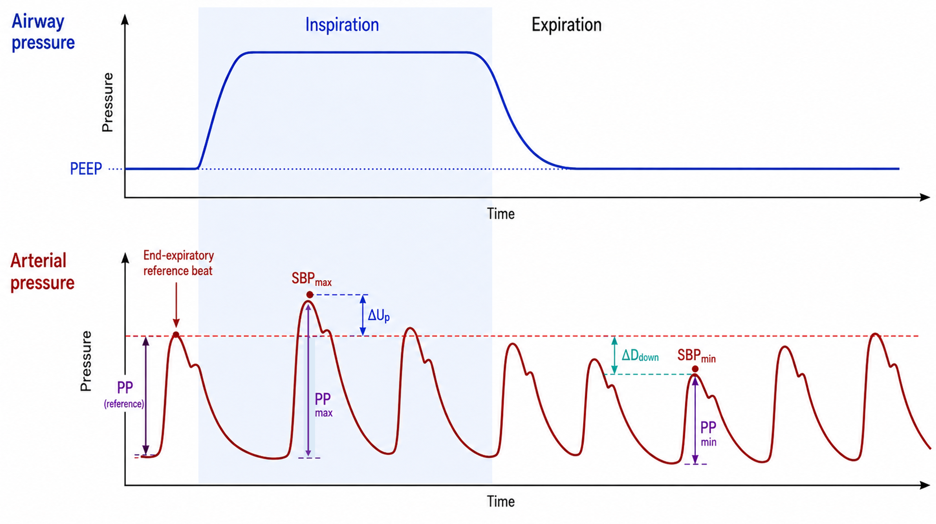

The experimental history is useful because it demonstrates how dynamic measurements outperformed the static filling pressures they were developed to replace. In the original animal experiments, SPV and especially ΔDown closely tracked graded blood removal even when right atrial and pulmonary artery occlusion pressures did not. Tavernier and colleagues subsequently studied patients with sepsis-induced hypotension and found that ΔDown predicted response to volume loading better than left ventricular end-diastolic area or pulmonary artery occlusion pressure; a ΔDown above 5 mmHg had high positive and negative predictive values in that small selected cohort.
SPV nevertheless carried two practical problems. First, separating ΔUp and ΔDown requires a reference systolic pressure during an expiratory pause, which prevents routine automatic measurement. Second, SPV is expressed as an absolute pressure difference in mmHg. A 10-mmHg swing does not mean the same thing when the baseline pulse pressure is 25 mmHg as when it is 70 mmHg. Pulse pressure variation solved much of that problem.

Pulse pressure variation: turning the waveform into a normalized signal
Part of the respiratory change in systolic pressure can reflect the direct transmission of intrathoracic pressure to the arterial system rather than a change in ejected volume. Pulse pressure reduces that common-mode effect because systolic and diastolic pressure from the same beat are exposed to approximately the same surrounding-pressure perturbation. Subtracting diastolic from systolic pressure therefore emphasizes the pulsatile pressure generated by ventricular ejection.
$$PP=SBP-DBP$$
And
$$PPV=100×\frac{PP_{max}-PP_{min}}{(PP_{max}+PP_{min})/2}$$where $PP_{max}$and $PP_{min}$are the largest and smallest pulse pressures over the respiratory cycle.

Normalizing the difference by its own mean makes PPV a percentage. This removes much of the problem created by comparing absolute pressure swings between patients with very different baseline pulse pressures and arterial compliance. This is the conceptual reason PPV displaced SPV for routine monitoring.
Michard and colleagues established the classic clinical result in 40 mechanically ventilated patients with acute circulatory failure related to sepsis. PPV was substantially greater in patients whose cardiac index subsequently increased with volume expansion, and a threshold of 13% separated responders from non-responders with high sensitivity and specificity in that tightly selected population. Volume expansion subsequently reduced PPV, and the magnitude of the fall tracked the increase in cardiac index.
The important part is not that 13% became a magic number. It is that a respiratory pressure signal contained information about the slope of the patient's starling curve.

Stroke volume variation: observing the flow signal directly
If PPV observes the pressure consequence of respiratory stroke-volume variation, SVV attempts to measure the stroke-volume variation itself.
$$SVV=100×\frac{SV_{max}-SV_{min}}{(SV_{max}+SV_{min})/2}$$
where $SV_{max}$and $SV_{min}$are the largest and smallest stroke volumes over the respiratory cycle.
Conceptually, SVV sits one step upstream of PPV. Positive-pressure ventilation creates the respiratory variation in stroke volume; the arterial system then converts that changing volume into a changing pulse pressure. PPV therefore includes information from both the cardiopulmonary generation of the stroke-volume oscillation and the arterial transformation of that oscillation into pressure. SVV attempts to report the first more directly.
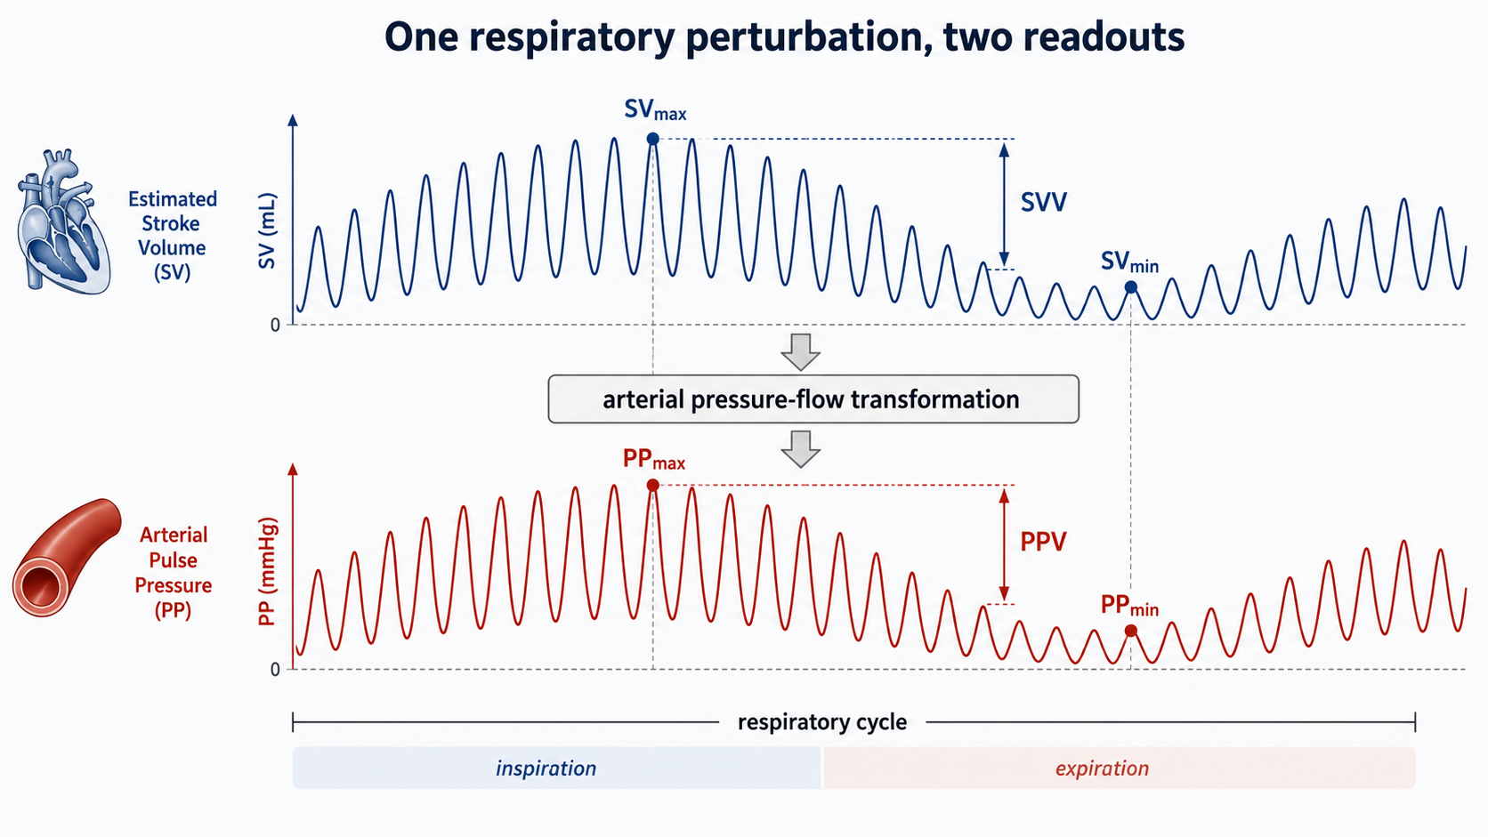
How independent that SVV signal really is depends on how stroke volume is measured. If the respiratory change in stroke volume is obtained from a genuinely independent flow measurement, such as an appropriate Doppler-derived aortic flow signal, it represents a separate observation of the same physiologic perturbation. If SVV is generated by a pulse-contour monitor from the same arterial pressure waveform used to calculate PPV, however, it is not an independent second opinion. It is a model-derived estimate built from the same waveform. This point becomes critical once PPV and SVV are divided by one another.
The historical thresholds are also not identical. In the 2009 pooled analysis, the mean threshold was approximately 12.5% for PPV and 11.6% for SVV. They should therefore not be taught as interchangeable indices with one universal threshold.

What PPV and SVV are actually asking
Both PPV and SVV are most useful when interpreted as preload-responsiveness tests. Their question is:
“If cardiac preload increases under these conditions, is stroke volume likely to increase?”

That is not the same as asking whether the patient is hypovolemic. A patient can be preload responsive with a normal or increased circulating volume. Nor does preload responsiveness mean the patient needs more cardiac output, that fluid is the appropriate way to increase preload, or that fluid administration would be safe. Those are separate clinical questions developed in Module I11.

This distinction matters because the dynamic indices can change without any restoration of lost blood volume. In an experimental hemorrhage study, norepinephrine reduced PPV and SPV despite the fact that none of the removed blood had been returned. Venoconstriction recruited stressed volume and changed the operating point of the circulation. At the same time, norepinephrine altered the arterial system through which the pressure signal was being generated. A falling PPV during vasopressor treatment is therefore not evidence that the vascular compartment has somehow been “filled.”
[PHYSIOLOGIC INSIGHT BOX]
A dynamic preload index is not a blood-volume meter. It reports how strongly stroke volume responds to a respiratory preload perturbation under the conditions in which it is measured. Fluid responsiveness, fluid requirement and fluid tolerance are different questions.
Where 12 or 13 percent comes from
A threshold is not a physiologic constant. It is the cut point that best separated responders from non-responders in a particular population, using a particular intervention, a particular definition of response, and a particular method of measuring stroke volume or cardiac output.
Michard's original study produced the familiar 13% PPV threshold. The 2009 pooled analysis of 29 studies and 685 patients found a mean PPV threshold of 12.5 ± 1.6%. A subsequent meta-analysis restricted to mechanically ventilated patients without spontaneous effort or arrhythmia and generally using larger tidal volumes found excellent discrimination. By contrast, the 2023 meta-analysis of 59 operating-room studies and 2,947 patients, with considerably broader populations and conditions, reported an overall area under the curve of only 0.77 and a mean threshold around 10.8%.
The apparent contradiction is useful. The best performance comes from the populations in which the physiologic assumptions are most tightly controlled. The diagnostic accuracy of PPV is therefore partly a property of the test and partly a property of the population in which we choose to apply it.
For this module, the practical formulation should be:
When classical validity conditions are satisfied, PPV values around 12–13% have traditionally supported preload responsiveness. When a protocol requires one operational value, 13% is a reasonable historical threshold and is the value used in ANDROMEDA-SHOCK 2. The number should not be interpreted independently of the conditions under which it was obtained.
SVV should retain its own threshold history rather than being assigned the same 12–13% value.

The grey zone
A single cutoff forces every patient into one of two categories, which misrepresents what a test does when its two distributions overlap. The grey zone approach reports instead the range of values within which the test does not classify reliably, together with the proportion of patients who land there. Applied to pulse pressure variation it produces the most useful single result in this literature.
In 413 patients under general anaesthesia across four centres, pulse pressure variation had an area under the curve of 0.89 against 0.57 for central venous pressure, and the grey zone ran from 9 to 13 percent, containing 98 patients or 24 percent of the cohort. In 556 patients pooled from nine French intensive care units the area under the curve was 0.73 and the grey zone ran from 4 to 17 percent, containing 62 percent. Those patients had already been selected for satisfying the validity prerequisites, and in them values across that whole range did not predict fluid responsiveness.
The practical reading of a grey zone value is not a small correction to the usual one. A pulse pressure variation of 11 percent in an intensive care patient is not a negative test, and it is not a weakly positive one either. It is a non-answer, and the response is to reach for a provocation whose assumptions the patient does satisfy, which is what the selection table in Module I11 is for. The commonest error is to treat a grey zone value as confirmation of whatever you were already inclined to do.
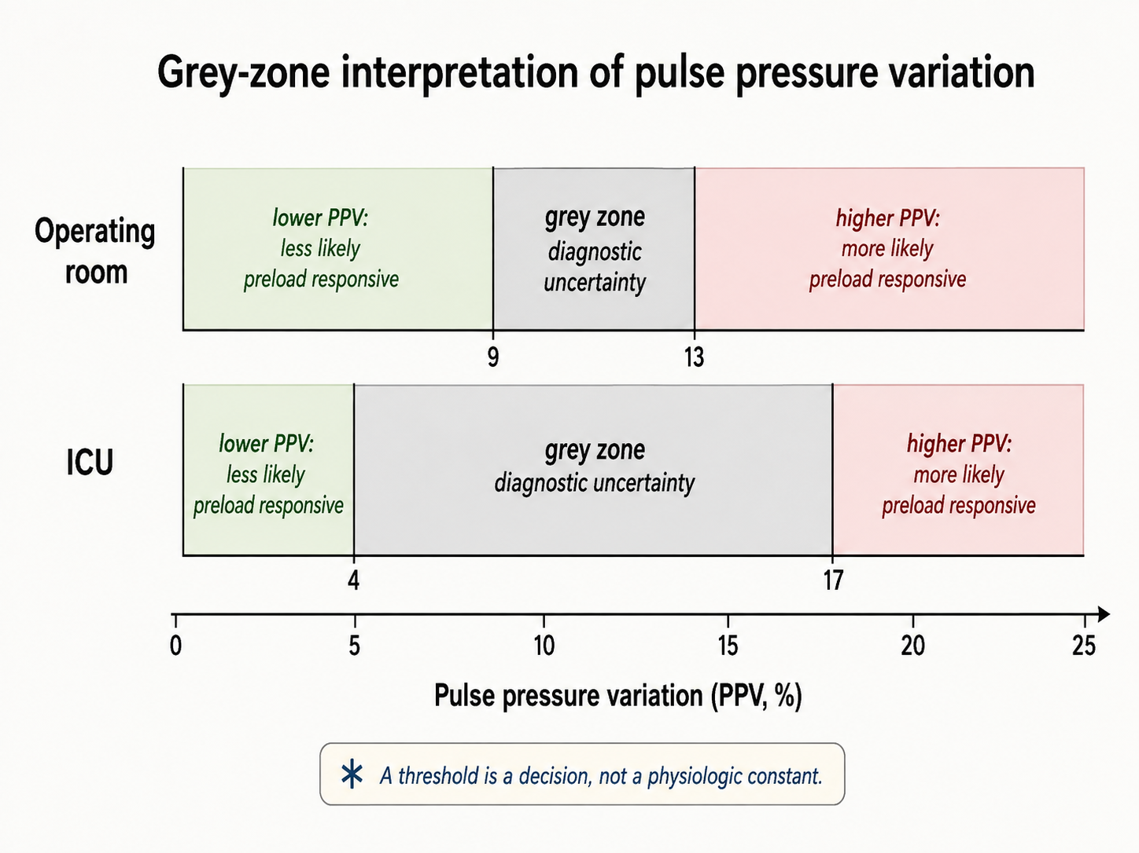
The same analysis shows what the cutoff ought to depend on. When the intensive care data were reanalysed weighting for the harm of giving fluid to a hypoxaemic patient who would not benefit, the grey zone shifted down to 2 to 13 percent, because the cost of a false positive had risen. A threshold is a decision, not a fact, and it should move with the consequences of being wrong in each direction.

The chain, link by link
Once the test is understood as a controlled physiologic experiment, its limitations become predictable. Each failure mode either changes the provocation, changes the cardiovascular response for the wrong reason, prevents the response from completing, alters the conversion from flow to pressure, or corrupts the measurement itself.

The breath must be controlled
The respiratory perturbation has to be sufficiently reproducible that the largest and smallest beats can reasonably be attributed to ventilation.

Spontaneous respiratory effort destroys that assumption. A spontaneous inspiration lowers rather than raises pleural pressure, and the magnitude of that pressure change varies from breath to breath. A patient intermittently triggering a ventilator may therefore receive a nominally controlled tidal volume while adding an unknown inspiratory effort of their own. The relevant criterion is not the name of the ventilator mode. It is whether the patient is passive during the respiratory cycles used for the measurement.
The empirical result is dramatic. In 21 critically ill patients with spontaneous respiratory movements, respiratory pulse-pressure variation ranged widely and did not distinguish fluid responders from non-responders; the area under the curve was 0.40.
There is a second mechanism for failure during spontaneous breathing. A strong inspiratory effort lowers right atrial pressure and increases the gradient for venous return only until the great veins themselves become flow-limited. Beyond that point, a larger pressure gradient does not necessarily produce more venous return. A patient may therefore generate a large inspiratory effort but little additional stroke-volume variation, creating a false sense of preload independence.

The perturbation must reach the pleural space
The traditional requirement of a tidal volume around 8 mL/kg predicted body weight arose because low tidal volumes can create a respiratory perturbation too small to expose preload responsiveness. In De Backer's study, a PPV threshold performed well above 8 mL/kg and essentially at chance below it. A small PPV measured during a 6-mL/kg breath therefore does not by itself establish preload independence.
But tidal volume is only a proxy for the variable that matters: how much pleural pressure actually changes.
The airway pressure applied by the ventilator is divided between expansion of the lung and deformation of the chest wall:
$$ΔP_{aw}≈ΔP_{L}+ΔP_{pl}$$
where $ΔP_{L}$is the change in transpulmonary pressure and $ΔP_{pl}$approximates the pressure transmitted to the pleural space.
This distinction is crucial. If the respiratory system is stiff predominantly because the lung is stiff, a relatively large airway pressure may be required to inflate the lung while comparatively little is transmitted to the pleural space. The cardiovascular provocation can therefore remain small despite an impressive airway pressure. If the respiratory system is stiff predominantly because the chest wall or abdomen is stiff, a larger fraction of airway pressure may instead appear as pleural pressure and the cardiovascular perturbation may be amplified.
A study of 54 patients with circulatory shock, including patients with ARDS, found that PPV performed very well when respiratory-system compliance was above 30 mL/cmH₂O but much less well below that value, whereas passive leg raising and end-expiratory occlusion retained substantially better discrimination. The 30-mL/cmH₂O threshold is useful empirically, but total respiratory-system compliance does not identify whether the reduced compliance comes from the lung or chest wall. The mechanism is therefore more informative than the cutoff.
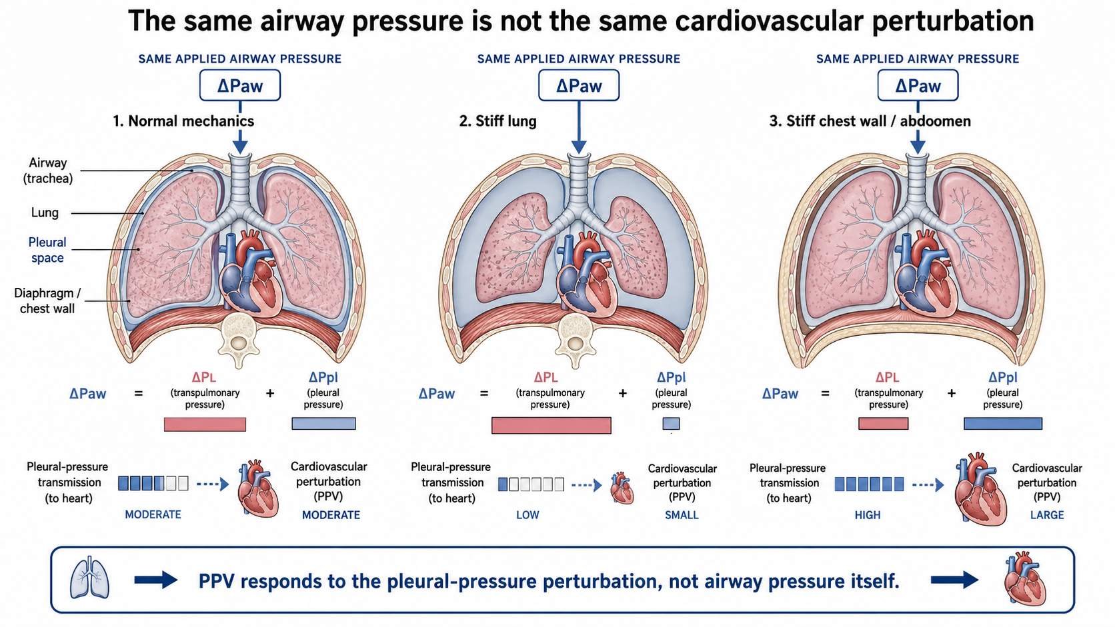
An open chest represents the limiting case in the opposite direction. When pressure surrounding the intrathoracic cardiovascular structures is no longer contained normally, mechanical ventilation no longer creates the same pleural-pressure perturbation. In patients studied during cardiac surgery, dynamic preload indices failed under open-chest conditions and recovered their predictive performance after closure.
Raised intra-abdominal pressure can amplify transmission rather than abolish it. Experimental studies in pigs show that the PPV threshold shifts upward markedly as abdominal pressure rises. Those experiments support the direction of the effect, but they do not establish a human correction factor or validated human threshold. A PPV of 14% in a patient with a tense abdomen should therefore not automatically be interpreted using the conventional cutoff.

The beats must be comparable
PPV and SVV assume that the dominant systematic difference among consecutive beats is their position within the respiratory cycle.
An arrhythmia breaks that assumption. In atrial fibrillation, variable filling time and preceding R-R intervals alter stroke volume independently of ventilation. The maximum and minimum pulse pressures in a respiratory window may therefore be selected by the rhythm rather than by the breath. There is no reliable direction to the resulting error, which makes the signal uninterpretable rather than merely biased high or low.
A high respiratory rate creates a different timing problem. The decrease in left ventricular filling caused by a decrease in right ventricular output takes several beats to traverse the pulmonary circulation. If there are too few cardiac cycles within one breath, the delayed trough generated by one respiratory cycle overlaps with the response to the next.
In 17 hypovolemic patients, raising respiratory rate while maintaining tidal volume markedly reduced PPV and respiratory variation in aortic flow despite no meaningful change in cardiac index or underlying preload status. Variation became very small when the heart-rate-to-respiratory-rate ratio fell below approximately 3.6. The right-sided respiratory signal persisted while the delayed left-sided signal was lost.
This is a particularly elegant demonstration that these indices are not labels attached to a patient. They are time-dependent measurements of a physiologic process.
The right ventricle must be able to tolerate the breath
A positive PPV or SVV is usually interpreted as evidence that stroke volume is changing because preload is changing along the steep part of the cardiac function curve. But positive-pressure inspiration also changes right ventricular afterload.
Lung inflation compresses alveolar vessels and increases the impedance against which the right ventricle ejects. A right ventricle with adequate reserve tolerates this additional load. A right ventricle already operating near its limit may instead decrease output substantially during inspiration even when additional preload will not increase cardiac output.
The arterial trace cannot identify why right ventricular output fell. It only sees the delayed consequence. A large respiratory variation can therefore arise because the RV is preload responsive, or because the RV is failing the inspiratory afterload challenge.
This produces a classic false positive. Mahjoub and colleagues studied 35 mechanically ventilated patients selected because PPV exceeded 12%. Twelve, approximately one third, did not increase stroke volume after volume expansion, and impaired right ventricular systolic function identified many of these false-positive PPV values.
Giving fluid in this setting may not simply fail to help. Additional preload can further dilate an already pressure-loaded right ventricle, increase wall stress, worsen interventricular septal displacement, and reduce left ventricular filling. The respiratory variation may then remain elevated or even increase, because each positive-pressure breath is acting on an RV that is now even less able to tolerate the transient rise in afterload. In other words, instead of PPV or SVV falling after volume loading as the heart moves toward the flatter portion of a preload-responsive function curve, failure of the indices to fall — or a paradoxical increase — should raise concern that the intervention has worsened right ventricular loading rather than corrected preload dependence.
Experimental data illustrate the principle. Acute pressure-overload RV failure increased both PPV and SVV, and during subsequent volume loading PPV decreased only in animals that actually increased cardiac output; in nonresponders it failed to fall. In patients with elevated pulmonary artery pressure, PPV was frequently high despite poor fluid responsiveness, and RV ejection fraction deteriorated during 44% of fluid challenges that failed to increase stroke volume.
The practical rule is therefore not merely “PPV positive = fluid responsive.” It is:
A large respiratory variation tells you that the breath is changing stroke volume. Before calling that change preload responsiveness, make sure the right ventricle is not failing the inspiratory afterload challenge. And after a fluid challenge, do not look only at cardiac output: PPV or SVV that fails to decrease, or rises further together with RV dilatation, is a warning that additional preload may be worsening RV physiology rather than recruiting stroke volume.

The arterial system must faithfully transform flow into pressure
Even if the respiratory stroke-volume variation is generated perfectly, PPV still depends on what happens after that changing stroke volume leaves the left ventricle. The arterial system does not simply display flow; it transforms each ejected volume into a pressure trace.
During systole, part of the stroke volume moves blood forward through the circulation and part transiently distends the elastic arteries. The pressure generated by that ejection therefore depends not only on how much blood was ejected, but also on the properties of the arterial system receiving it. As a useful first approximation:
$$PP≈\frac{SV}{C_{art}}$$where $PP$ is pulse pressure, $SV$ is stroke volume, and $C_{art}$ is total arterial compliance. For the same change in ejected volume, a less compliant arterial tree tends to generate a larger change in pressure, whereas a more compliant system can accommodate more volume with a smaller pressure rise.
That approximation is deliberately simple. In the real circulation, characteristic impedance, systemic vascular resistance, peripheral runoff, wave transmission and reflection, and the timing and acceleration of ventricular ejection also influence the pressure generated by each beat. But the central idea is the same: the stroke-volume oscillation is created by the cardiopulmonary interaction, while the arterial system determines how strongly that oscillation appears as pressure.
Over a single respiratory cycle, most of these arterial properties change little enough that PPV and SVV usually move in the same direction. When stroke volume rises, pulse pressure tends to rise; when stroke volume falls, pulse pressure tends to fall. This is why PPV can serve as a useful pressure-based surrogate of respiratory stroke-volume variation.
But PPV and SVV are not the same signal.
SVV tells us how much stroke volume is changing. PPV tells us how much pulse pressure is changing as a consequence of that stroke-volume oscillation. Between the two sits the ventricular–arterial interaction.
This means that two patients can have the same respiratory variation in stroke volume and yet show very different respiratory variations in pulse pressure. If the arterial system converts a given change in ejected volume into a relatively large pressure change, PPV will be prominent. If the same change in stroke volume produces only a modest pressure change, PPV will be smaller even though the underlying SVV may be just as large.
This distinction becomes clinically important in vasodilatory states. A patient can remain markedly preload responsive, with a large respiratory oscillation in stroke volume, while the accompanying pulse-pressure oscillation is comparatively modest because changes in ejected volume are producing relatively small changes in arterial pressure under the prevailing cardiovascular conditions. In that setting, PPV can underrepresent the magnitude of the underlying stroke-volume variation.
A modest PPV therefore does not always mean that stroke volume is stable. SVV may still be large. The two measurements are simply reporting different parts of the same process: one observes the respiratory variation in flow, while the other observes how strongly that variation is expressed as pressure.
This is not necessarily a measurement error. The arterial waveform may be faithfully reporting the physiology: stroke volume is changing substantially, but pressure is changing much less. That distinction is particularly relevant in highly vasodilatory states, where a circulation may be highly responsive in terms of flow without generating an equally large pressure response.
[Physiologic Insight box: PPV and SVV are related, but they are not interchangeable. SVV describes the respiratory oscillation in stroke volume; PPV describes the pressure oscillation produced by that changing stroke volume. A large SVV can therefore coexist with a comparatively modest PPV when changes in flow are translated into relatively small changes in arterial pressure.]
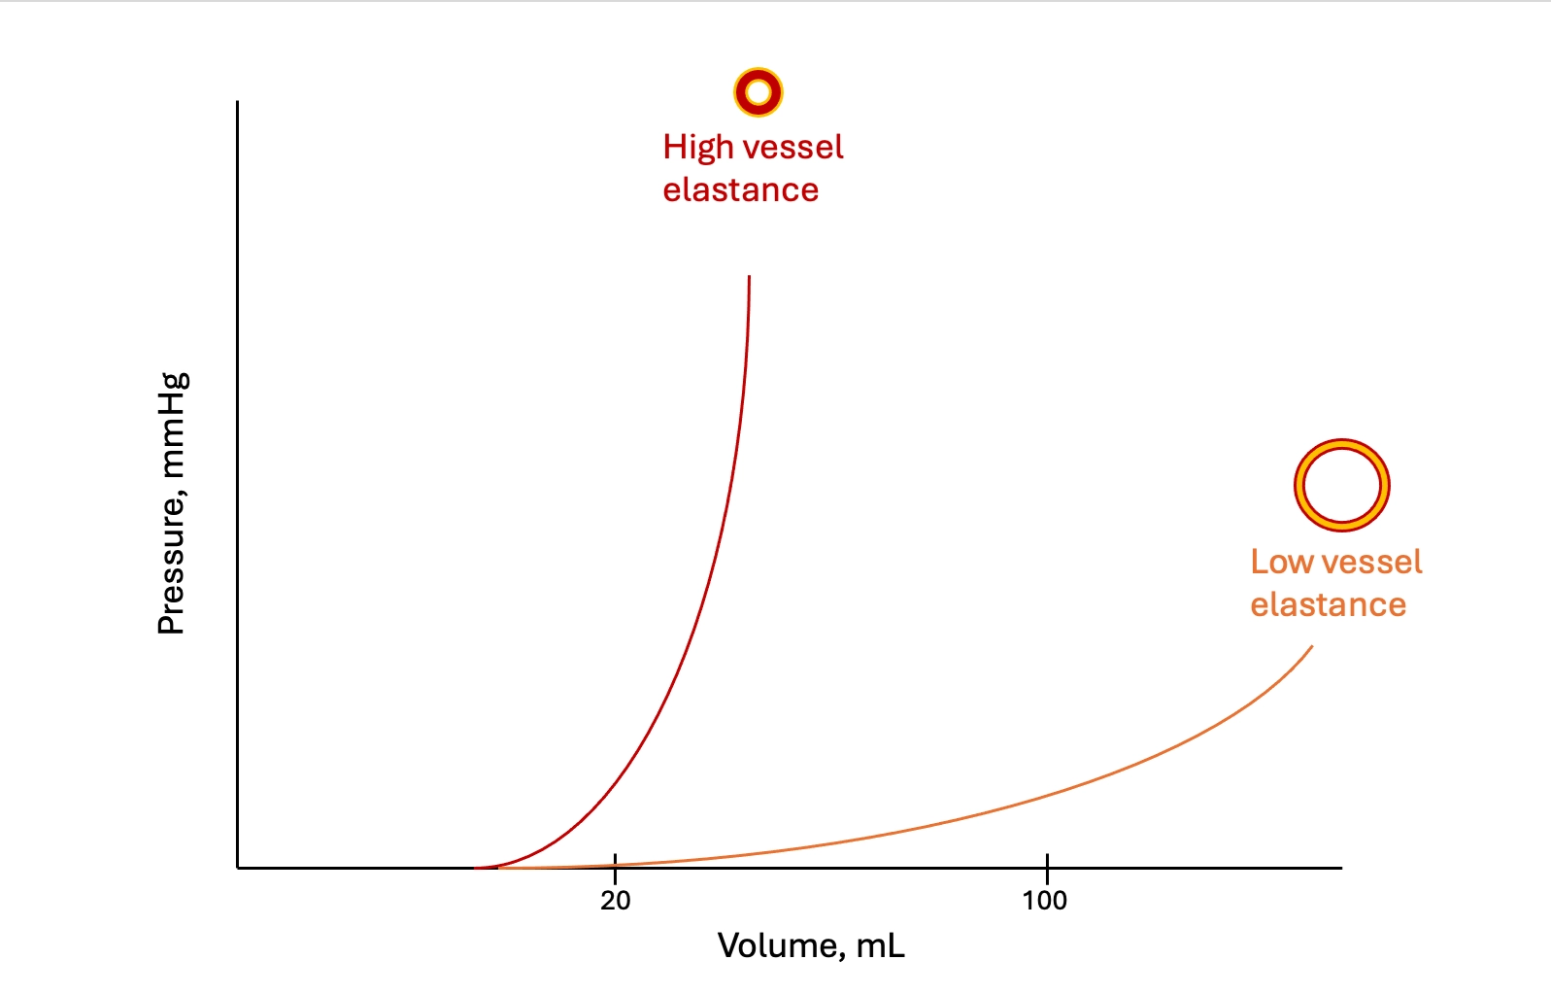

Vasoactive therapy further complicates this relationship because it can affect both sides of it. Norepinephrine may recruit stressed volume and move the operating point of the heart, changing the magnitude of the stroke-volume oscillation, while simultaneously changing arterial loading conditions and therefore the pressure generated by each ejection. PPV can consequently change because the respiratory stroke-volume oscillation changed, because the arterial transformation of that oscillation changed, or because both changed together.
This is why PPV should not be viewed simply as SVV expressed through an arterial catheter. PPV contains two pieces of physiology: the upstream cardiopulmonary generation of the stroke-volume oscillation and the downstream transformation of that oscillation into arterial pressure.
The useful question at this point is therefore:
For the stroke-volume variation that is actually occurring, how much pulse-pressure variation is the arterial system generating?
The waveform itself must be real
Everything above assumes that the waveform on the monitor faithfully represents arterial pressure.
An underdamped or resonant catheter-transducer system exaggerates systolic pressure and depresses diastolic pressure, widening pulse pressure. Because the distortion depends partly on waveform frequency content and upstroke characteristics, it may also distort respiratory variation. An overdamped system does the opposite, narrowing pulse pressure and blunting variation.
The fast-flush test therefore comes before interpretation of a waveform-derived index.
Sampling site matters as well. Pulse pressure changes as the wave travels from the aorta toward the periphery. A radial pressure waveform is not a scaled copy of the central aortic waveform, and disease or vasoactive therapy can change that relationship. Module I4 develops pressure amplification and arterial-wave mechanics, while I6 adds the special problem of abnormal central-to-peripheral coupling during septic physiology.
[Offshoot / At-the-Bedside link: Before reading either index, change how the trace is displayed. The default sweep speed is chosen to show the shape of a single beat, which is the wrong setting for a signal whose period is a whole breath. Slow it until two or three respiratory cycles fit across the screen, and expand the pressure scale so the swing occupies a usable fraction of the height. Variation that is invisible at 25 mm per second on a 0 to 200 mmHg scale is obvious once both are adjusted, and a displayed number should always be checked against a trace you have looked at yourself.]
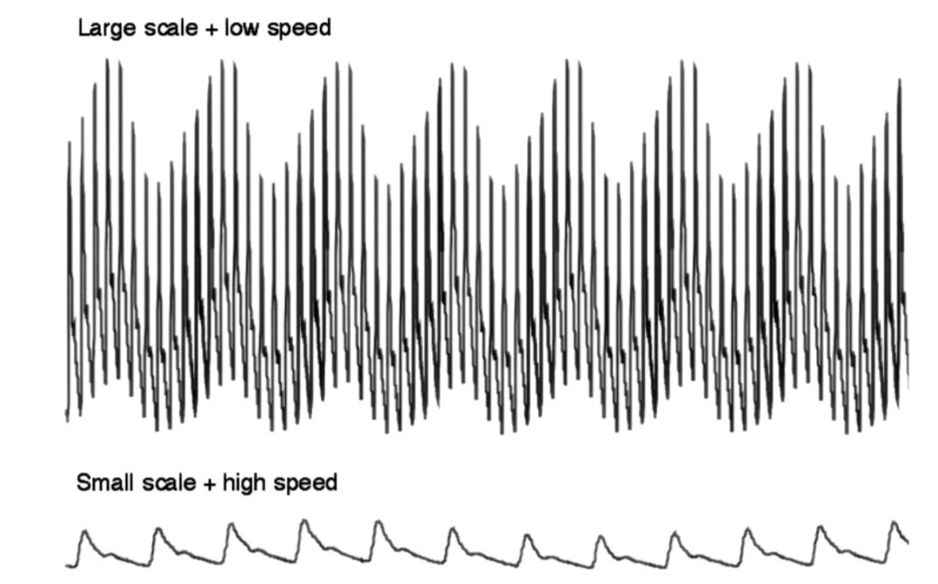

When the level is uncertain, change the experiment
Several limitations of a single PPV or SVV value can be handled by deliberately changing one component of the experiment and observing the response. The patient becomes their own control.
The tidal volume challenge changes the provocation and holds the patient fixed. In a patient ventilated at 6 mL/kg where the index is uninterpretable, tidal volume is raised to 8 mL/kg for one minute, the absolute change is recorded, and the setting is returned. In thirty measurements across twenty patients with acute circulatory failure, a rise in pulse pressure variation of 3.5 percent identified responders with an area under the curve of 0.99, and a rise in stroke volume variation of 2.5 percent gave 0.97. In the same patients at the same moment, both indices, the central venous pressure and the end-expiratory occlusion test measured at 6 mL/kg predicted nothing at all. The interpretation follows from the proportionality: raising the tidal volume raises the first factor by a known proportion, so the resulting change reports the second, the slope of the function curve.
A passive leg raise read on the arterial line changes the operating point and holds the provocation fixed. In a preload responsive patient the leg raise moves the operating point towards the flatter part of the curve, where the same respiratory stimulus produces a smaller swing, so the index should fall and by how much reports responsiveness. In thirty patients without spontaneous breathing or arrhythmia, ventilated at 6 mL/kg, the change in pulse pressure variation during a leg raise detected preload responsiveness with an area under the curve of 0.98, expressed either as an absolute or a relative change. That converts the leg raise, whose usual limitation is needing a real-time flow monitor, into a test doable with an arterial line alone, so a leg raise read as a fall in pulse pressure variation of 2 percent absolute or 20 percent relative can indicate an effective increase in CO.
Reading the trend is the least formal and the most often available. Michard's original study found that volume expansion halved the variation and that the fall correlated with the rise in cardiac index. A variation that falls as fluid is given, ventilator settings unchanged, reports that the operating point has moved along the curve. One that does not fall despite an adequate challenge reports that it has not. Neither reading needs the absolute value to be interpretable against a threshold, which is why the kinetics survive conditions the level does not.
Two things have no workaround. An arrhythmia defeats the tidal volume challenge as thoroughly as it defeats the static index, because the quantity read is still a beat-to-beat comparison. And an open chest defeats every ventilator-based manoeuvre, because there is no provocation to modulate. In both cases the answer is a test that does not use the ventilator at all, set out in Module I11.
The level also moves with drugs, in a direction easy to misread as progress. In six dogs bled 35 mL/kg, pulse pressure variation rose from 12 to 28 percent and systolic pressure variation from 12.5 to 21 mmHg, while right atrial and pulmonary artery occlusion pressures did not move at all. Norepinephrine then raised cardiac output and significantly reduced both dynamic indices without restoring any of the lost blood volume. The mechanism is the one Module I8 develops, recruitment of unstressed into stressed volume, which slides the patient along the same function curve towards its flatter part. A variation that falls while the vasopressor dose is being escalated has not shown that the patient has been filled. Vasodilators, in the other hand, may shift the indices in the opposite direction, but the effect depends on their simultaneous influence on venous return, ventricular loading and arterial pressure–flow transformation.

From preload responsiveness to pressure responsiveness
Up to this point the question has been about flow:
If preload increases, will stroke volume increase?

But hypotension creates a second question:
If stroke volume increases, will arterial pressure increase meaningfully?

Those questions are not equivalent.
A fluid challenge can increase stroke volume and cardiac output without producing much increase in arterial pressure. Conversely, a relatively small change in flow can generate a substantial pressure change in another cardiovascular state. The difference lies in how the ventricle and arterial system interact to convert ejected flow into pressure.
PPV and SVV give us a way to look at that transformation during the same respiratory cycle.
$$E_{a,dyn}=\frac{PPV}{SVV}$$
Dynamic arterial elastance, $E_{a,dyn}$, is therefore a dimensionless ratio of the relative respiratory change in pulse pressure to the relative respiratory change in stroke volume.
If SVV is 15% and PPV is also 15%,
$$E_{a,dyn}=1.0$$
If another patient has the same SVV of 15% but a PPV of only 7.5%,
$$E_{a,dyn}=0.5$$
The respiratory flow variation is the same, but the pressure response is not.
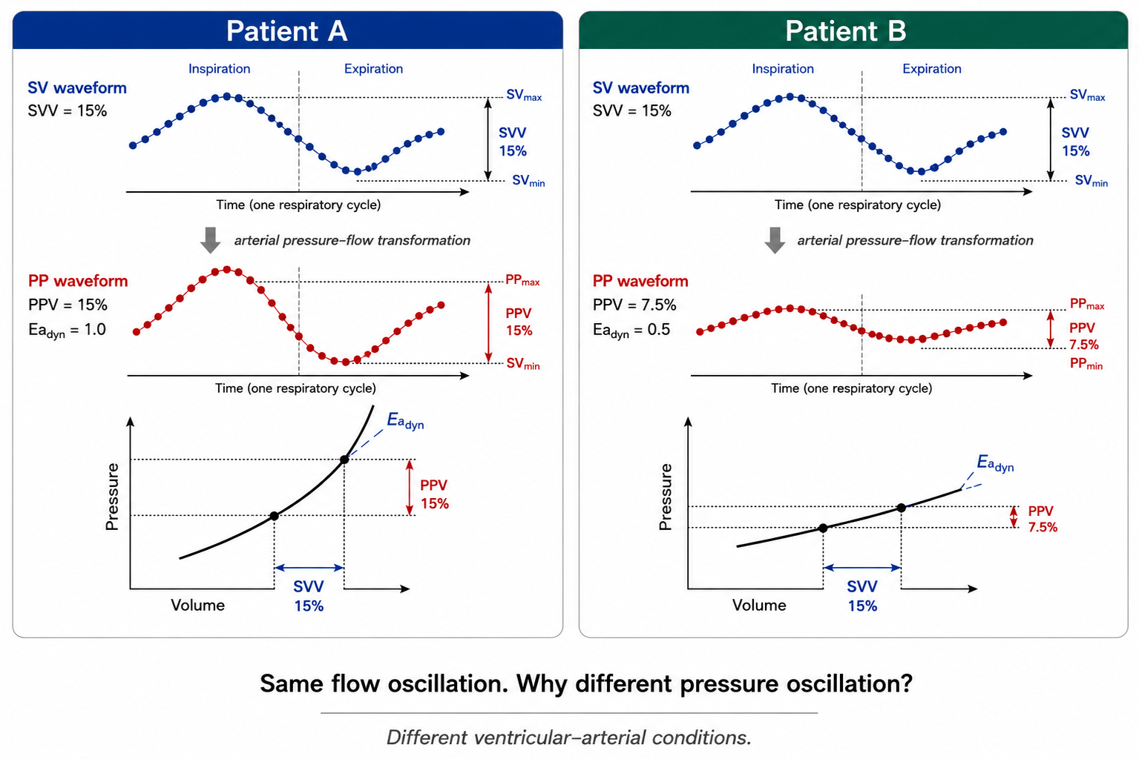
This is the most important way to understand EaDyn:
EaDyn describes how strongly a respiratory change in stroke volume is being translated into a respiratory change in pulse pressure under the current ventricular–arterial conditions.

Dynamic arterial elastance is not effective arterial elastance
The name is unfortunately easy to misinterpret.
Effective arterial elastance, $E_{a}$, introduced earlier in the pathway, is commonly approximated as
$$E_{a}≈\frac{P_{es}}{SV}$$and is a lumped descriptor of the arterial load presented to the ventricle.
Dynamic arterial elastance is
$$E_{a,dyn}=\frac{PPV}{SVV}$$and is unitless because both numerator and denominator are percentages.
The two quantities are therefore neither mathematically nor physically interchangeable.

 | Effective arterial elastance Ea  ​ | Dynamic arterial elastance Ea,dyn  ​
Expression | Pes​/SV | PPV/SVV
Units | Pressure/volume | Dimensionless
Time scale | Beat/global loading state | Respiratory variation over several beats
Main concept | Lumped effective arterial load | Relative pressure response to a relative SV oscillation
Not equivalent to | Pure arterial stiffness | Ea, SVR, or pure vascular tone

The earliest clinical literature often described EaDyn as a dynamic measure of arterial tone. That interpretation is too simple. In an experimental study led by Monge and colleagues in which arterial load was deliberately changed, phenylephrine decreased EaDyn while nitroprusside increased it, and both arterial and cardiac factors contributed to the ratio. The investigators therefore argued that EaDyn was better understood in the context of ventricular–arterial interaction rather than as a direct measure of vascular tone.
Subsequent pressure-volume-loop experiments found significant relationships between EaDyn, conventional ventricular–arterial coupling and left ventricular mechanical efficiency across changes in preload, afterload and contractility. Those data make ventricular–arterial interaction a compelling mechanistic framework, but they do not turn EaDyn into a direct bedside measurement of $E_{a}/E_{es}$. It remains an indirect, dynamic pressure–flow signal.
[PHYSIOLOGIC INSIGHT BOX]
Do not read the name literally. A high EaDyn does not simply mean “high arterial elastance” or “high SVR,” and a low EaDyn does not simply mean vasoplegia. The ratio contains information from the ventricle, the arterial tree, the respiratory perturbation and the methods used to calculate both PPV and SVV.

What the clinical studies actually show
The original clinical use of EaDyn was not to decide whether a patient was preload responsive. Patients were generally selected because preload responsiveness had already been established. The ratio was then used to ask the next question: if stroke volume rises with volume expansion, will mean arterial pressure rise as well?

In the 2014 validation study, EaDyn predicted a greater than 10% increase in MAP after volume expansion in mechanically ventilated, preload-dependent patients. Importantly, the investigators addressed mathematical coupling by deriving PPV from the arterial pressure waveform while obtaining SVV using an independent esophageal-Doppler flow measurement. The reported cutoff was approximately 0.73, with a grey zone around 0.72–0.88.

A 2021 systematic review included eight observational studies, 323 patients and 361 volume expansions. Overall discrimination for MAP response was good, with an AUHSROC of 0.92, but reported cutoffs ranged from 0.65 to 0.89. Performance was substantially better in ICU cohorts than in operating-room cohorts. This is not evidence for a universal 0.8 threshold; it is evidence that the signal has predictive information under selected conditions and that its operating characteristics depend on context.

The norepinephrine literature asks a related but different question. In resuscitated septic-shock patients undergoing norepinephrine reduction, lower EaDyn values were associated with a greater fall in MAP after norepinephrine was decreased; in one early study a value below approximately 0.94 predicted the pressure decrease.

A subsequent randomized study in post-cardiac-surgery vasoplegia used an EaDyn-based algorithm during norepinephrine withdrawal. Norepinephrine treatment after enrollment was shorter in the intervention group, 17 versus 39 hours, and ICU stay was also shorter, without clear differences in lactate or central venous oxygen saturation.

Those early results are encouraging, but newer evidence makes the appropriate conclusion substantially more cautious. A 2024 meta-analysis of five prospective studies and 183 patients reported strong discrimination for the MAP response to norepinephrine weaning, with cutoffs ranging approximately from 0.80 to 0.97, but emphasized the limited evidence base.

In contrast, a 2025 real-world retrospective analysis of 542 critically ill patients encompassing 3,867 vasopressor de-escalation events found essentially no predictive discrimination from FloTrac-derived EaDyn: AUROC 0.50, with virtually identical baseline values in patients who did and did not develop hypotension after vasopressor reduction. The investigators specifically raised mathematical coupling and platform dependence as important concerns.

And in a 2025 randomized trial during major abdominal surgery, an EaDyn-based hemodynamic strategy changed the balance between fluid and vasopressor administration but did not improve the trial's primary postoperative lactate endpoint or reduce postoperative complications.

The practical interpretation is therefore deliberately modest:

EaDyn is a physiologically interesting pressure–flow coupling signal with evidence for predicting pressure responsiveness in selected populations. It is not a universally validated treatment target and should not by itself decide fluid administration or vasopressor titration.

Mathematical coupling: two numbers do not necessarily mean two measurements
EaDyn is a ratio, and a ratio cannot create independence that was absent from its inputs.

If PPV and SVV are both generated from the same arterial waveform by the same pulse-contour system, part of their relationship may be imposed by the algorithms used to derive them. This is the mathematical-coupling concern that led the early investigators to repeat validation using an independently measured SVV signal.

That does not make waveform-derived EaDyn meaningless. It means its performance is device- and algorithm-dependent, and a value from one platform cannot automatically be treated as physiologically interchangeable with a value obtained by combining arterial PPV with independently measured stroke-volume variation.

The large negative 2025 FloTrac study makes that caution especially relevant.
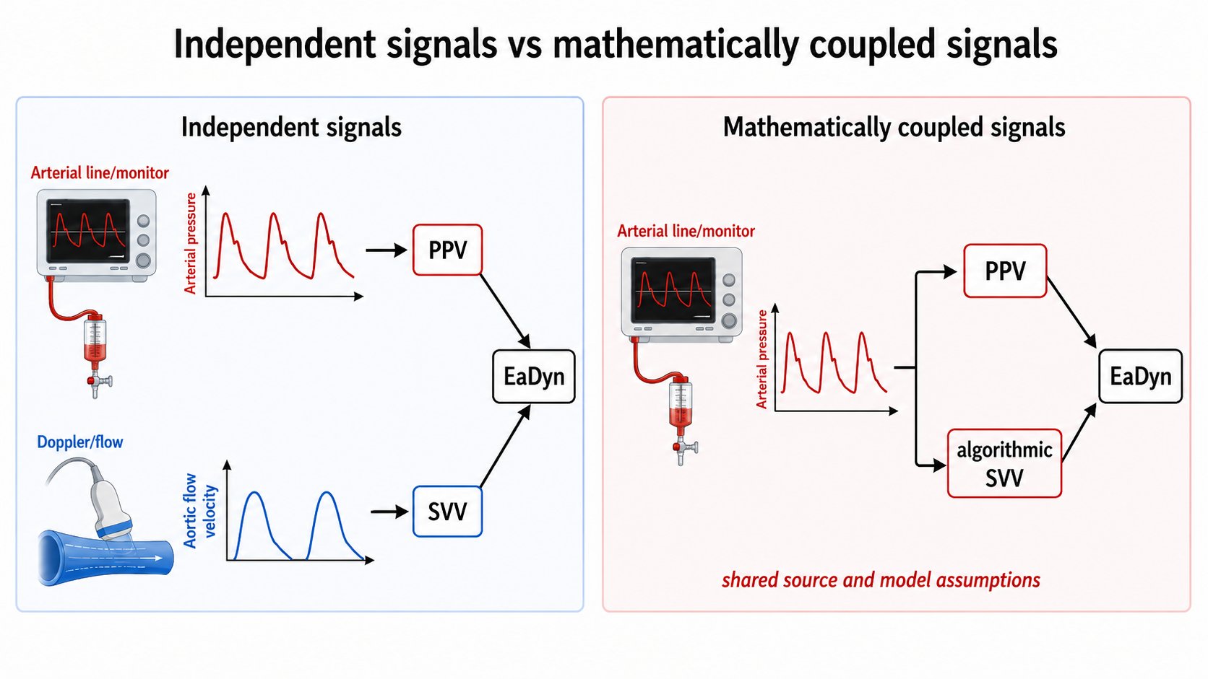

Putting the dynamic signals in the right clinical order
These measurements become easiest to use when each is allowed to answer only the question it was built to answer.

Perfusion assessment comes first. A patient who does not need an increase in flow does not benefit merely because a dynamic index says that flow could increase.

If an increase in flow is potentially useful, the next question is preload responsiveness: will increasing preload increase stroke volume? PPV, SVV, PLR, tidal-volume challenge and the other dynamic tests live here.

If stroke volume is likely to rise but arterial pressure is also an important target, a separate question follows: will that increase in stroke volume translate into a meaningful increase in pressure? EaDyn may contribute here, but with the methodological and population-specific limitations developed above.

Finally, even when preload responsiveness and pressure responsiveness are present, the intervention still has to be appropriate and tolerable. Fluid responsiveness is not fluid tolerance, and the best way to increase effective preload may not always be intravenous fluid.
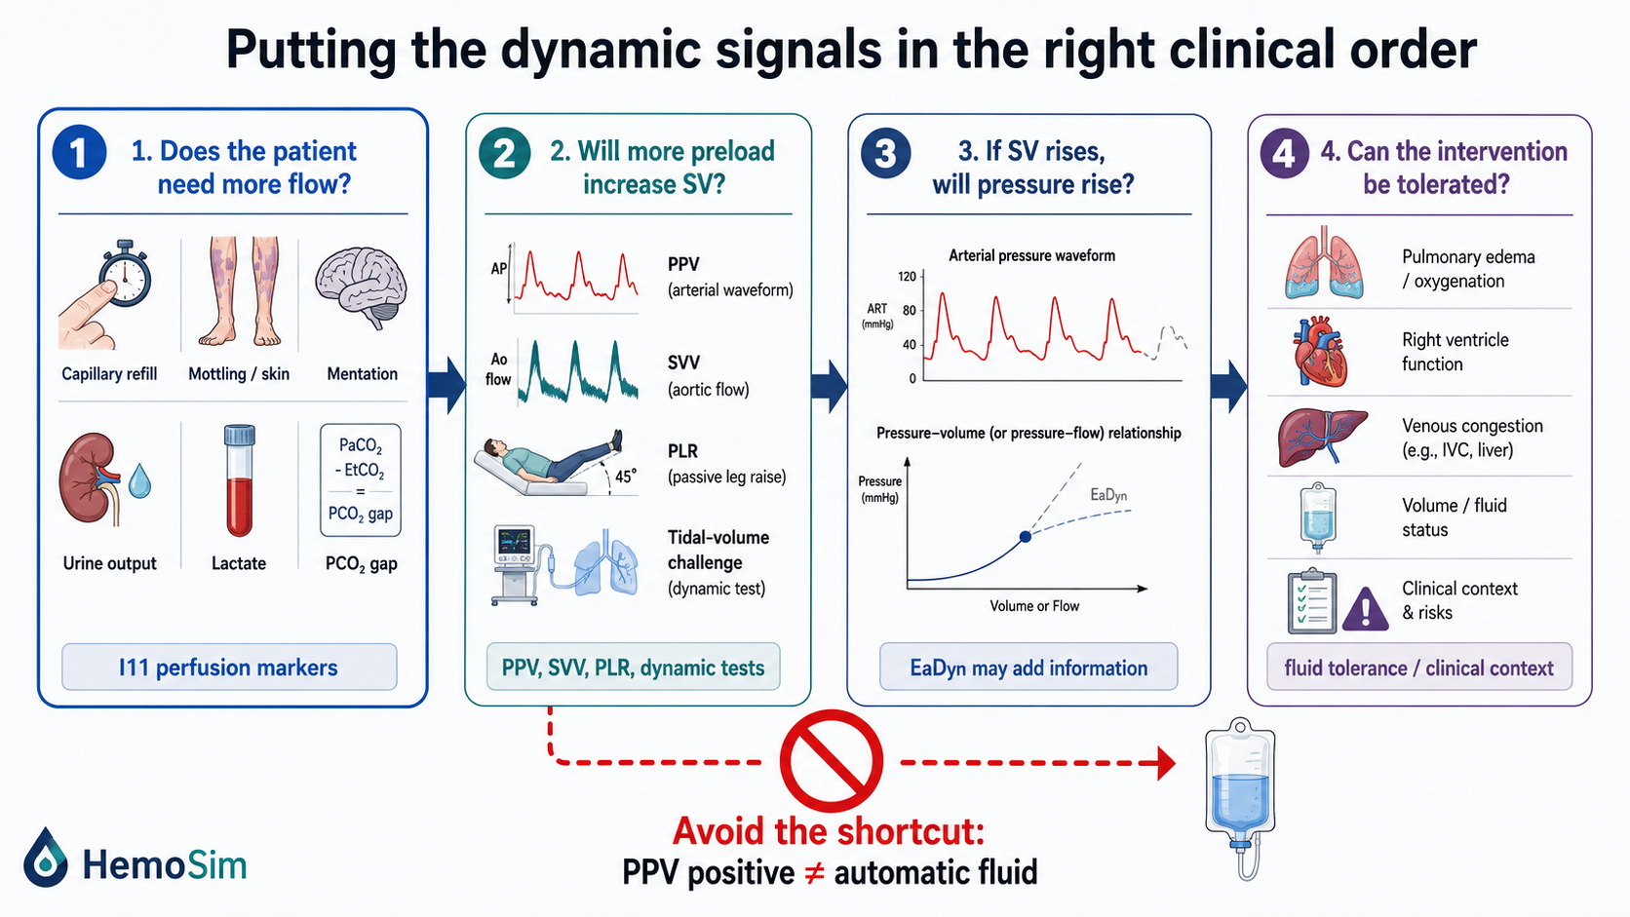

Putting a number in front of a patient
The table below summarises what has been derived rather than substituting for it. Its value is in the middle columns: knowing the direction of the error lets you act on a number you cannot fully trust, and knowing the broken link lets you choose a replacement test rather than guess at one.
Condition | What breaks | Likely effect | What to do instead
Spontaneous effort or a triggered breath | Respiratory provocation has variable size and sign | Unpredictable, and the index inverts. Area under the curve 0.40 | Use a provocation that does not require passive controlled breathing: Passive leg raise read as a change in flow, or a fluid challenge
Low tidal volume (about <8 mL/kg) | Pleural pressure perturbation may be too small | False negative | Tidal volume challenge, or occlusion tests, or a PLR
Low respiratory system compliance, especially lung-dominant stiffness (≤ 30 mL/cmH2O) | Airway pressure may be poorly transmitted to the pleural space | False negative/reduced sensitivity. Area under the curve falls to 0.69 | PLR or EEOT, both unaffected
Arrhythmia | Beat-to-beat SV changes independently of respiration | Uninterpretable in either direction | EEOT, or a PLR read across several beats (5). Both methods not based on respiratory beat comparison
Heart rate to respiratory rate ratio below 3.6 | Delayed RV→LV signal cannot fully develop | False negative | Lower the RR if clinically appropriate or choose another test
RV failure / marked RV afterload sensitivity | Respiratory SV change occurs for RV afterload rather than preload reason | False positive, in about a third of positive tests | Evaluate RV first; use an alternative preload test like a PLR or EEOT
Open chest or open pericardium | Normal pleural-pressure provocation is lost | False negative, and every ventilator-based test fails | Ventilator-based dynamic indices unreliable. Fluid challenge may be conducted as a formal test
Raised intra-abdominal pressure | Pleural-pressure transmission may be amplified | Conventional cutoff may become falsely positive | Leg raise or occlusion test, since the threshold in humans is unknown
Underdamped or overdamped arterial line | The trace is not the actual pressure in the artery | Inflated by resonance, abolished by overdamping | Fast flush test and fix the fluid path before reading anything
Major changes in arterial properties or vasoactive therapy | ΔSV→ΔPP transformation changes | PPV may change independently of preload status | Interpret PPV with SVV, hemodynamic context and trend
PPV and SVV generated from the same waveform | Shared algorithmic assumptions | EaDyn may be mathematically coupled | Interpret as platform-specific, not two independent measurements
[Offshoot / At-the-Bedside link: , in order. Look at the ventilator before the monitor: mode, set and delivered tidal volume, respiratory rate, plateau pressure and total positive end-expiratory pressure, and whether any breaths are being triggered. Compute respiratory system compliance and the heart rate to respiratory rate ratio, because both take seconds and both determine whether the number means anything. Look at the rhythm strip. Flush the arterial line and watch the square wave. Only then look at the trace, slowed and expanded, and confirm that what the monitor calls variation is a swing repeating once per breath rather than once every few beats. If the conditions hold and the value is clearly outside the grey zone, you have an answer. If a condition fails, name the link it broke and pick the replacement test from the last column, rather than discounting the number by an unspecified amount.]

What the measurement is actually good for
The history of PPV illustrates how a useful physiologic measurement can become less useful when its original assumptions are forgotten. It began as an alternative to static filling pressures and dramatically outperformed them in carefully selected ventilated patients. It then became a threshold, often applied to anyone who happened to have an arterial catheter. The modern interpretation is more useful: PPV and SVV are dynamic signals whose absolute level is highly informative under controlled conditions and whose response to a deliberate perturbation can remain useful when the baseline level is ambiguous.

The deepest principle underneath them is not the 13% threshold. It is that positive-pressure ventilation supplies a repeated hemodynamic perturbation and the cardiovascular response depends on transmural pressure, ventricular function, the operating point of the circulation and the arterial system through which ejected flow becomes pressure. The monitor sees only the final waveform.

EaDyn extends that same logic one step further. Once we recognize that a respiratory change in stroke volume and a respiratory change in pulse pressure are not identical signals, their relationship becomes physiologically interesting. But the ratio is only as trustworthy as the two measurements from which it is built, and its clinical meaning depends on the cardiovascular state in which it is measured.

The practical conclusion is therefore not “PPV above 13% means fluid,” nor “EaDyn above 0.8 means pressure responsive.” It is simpler and more demanding:

Know what was perturbed, know what was measured, know what transformed the signal in between, and ask only the question that the measurement is capable of answering. Hold that and you can reason about a case that appears on no list, which was the point of teaching it as a mechanism rather than as a rule.

The venous side carries its own respiratory signal and its own reading convention, and Module I14 takes up the right atrial waveform, where the same end-expiratory reference established in Module I3 is what makes one patient's a wave comparable to another's. Module I15 then applies the same discipline to the wedge, where the chain of assumptions is longer still and the transmission of airway pressure decides whether the number is a left atrial pressure or an echo of the ventilator. The full integration, across the chest wall and through the pulmonary circulation, with the disease scenarios that make heart-lung interaction pathological rather than merely measurable, belongs to the Expert pathway.

References
To DROP a reference, strike it. To ADD one, write [add: author, year, journal, roughly what it is] rather than typing the citation out. Do not correct the text of an entry here: every author list, volume, issue, page range, year and DOI is fetched from PubMed when the page is rebuilt, so an edit made here is discarded and a typo made here is caught. This list is what the page currently carries.

- Perel A, Pizov R, Cotev S. Systolic blood pressure variation is a sensitive indicator of hypovolemia in ventilated dogs subjected to graded hemorrhage. Anesthesiology. 1987;67(4):498-502. doi:10.1097/00000542-198710000-00009.
- Pizov R, Ya'ari Y, Perel A. Systolic pressure variation is greater during hemorrhage than during sodium nitroprusside-induced hypotension in ventilated dogs. Anesth Analg. 1988;67(2):170-174. PMID 3341566.
- Tavernier B, Makhotine O, Lebuffe G, Dupont J, Scherpereel P. Systolic pressure variation as a guide to fluid therapy in patients with sepsis-induced hypotension. Anesthesiology. 1998;89(6):1313-1321. doi:10.1097/00000542-199812000-00007.
- Michard F, Boussat S, Chemla D, Anguel N, Mercat A, Lecarpentier Y, Richard C, Pinsky MR, Teboul JL. Relation between respiratory changes in arterial pulse pressure and fluid responsiveness in septic patients with acute circulatory failure. Am J Respir Crit Care Med. 2000;162(1):134-138. doi:10.1164/ajrccm.162.1.9903035.
- Michard F, Teboul JL. Using heart-lung interactions to assess fluid responsiveness during mechanical ventilation. Crit Care. 2000;4(5):282-289. doi:10.1186/cc710. Free full text.
- Michard F. Changes in arterial pressure during mechanical ventilation. Anesthesiology. 2005;103(2):419-428. doi:10.1097/00000542-200508000-00026.
- De Backer D, Heenen S, Piagnerelli M, Koch M, Vincent JL. Pulse pressure variations to predict fluid responsiveness: influence of tidal volume. Intensive Care Med. 2005;31(4):517-523. doi:10.1007/s00134-005-2586-4.
- Nouira S, Elatrous S, Dimassi S, Besbes L, Boukef R, Mohamed B, Abroug F. Effects of norepinephrine on static and dynamic preload indicators in experimental hemorrhagic shock. Crit Care Med. 2005;33(10):2339-2343. doi:10.1097/01.ccm.0000182801.48137.13.
- Heenen S, De Backer D, Vincent JL. How can the response to volume expansion in patients with spontaneous respiratory movements be predicted? Crit Care. 2006;10(4):R102. doi:10.1186/cc4970. Free full text.
- de Waal EE, Rex S, Kruitwagen CL, Kalkman CJ, Buhre WF. Dynamic preload indicators fail to predict fluid responsiveness in open-chest conditions. Crit Care Med. 2009;37(2):510-515. doi:10.1097/CCM.0b013e3181958bf7.
- Renner J, Gruenewald M, Quaden R, Hanss R, Meybohm P, Steinfath M, Scholz J, Bein B. Influence of increased intra-abdominal pressure on fluid responsiveness predicted by pulse pressure variation and stroke volume variation in a porcine model. Crit Care Med. 2009;37(2):650-658. doi:10.1097/CCM.0b013e3181959864.
- De Backer D, Taccone FS, Holsten R, Ibrahimi F, Vincent JL. Influence of respiratory rate on stroke volume variation in mechanically ventilated patients. Anesthesiology. 2009;110(5):1092-1097. doi:10.1097/ALN.0b013e31819db2a1.
- Mahjoub Y, Pila C, Friggeri A, Zogheib E, Lobjoie E, Tinturier F, Galy C, Slama M, Dupont H. Assessing fluid responsiveness in critically ill patients: false-positive pulse pressure variation is detected by Doppler echocardiographic evaluation of the right ventricle. Crit Care Med. 2009;37(9):2570-2575. doi:10.1097/CCM.0b013e3181a380a3.
- Wyler von Ballmoos M, Takala J, Roeck M, Porta F, Tueller D, Ganter CC, Schröder R, Bracht H, Baenziger B, Jakob SM. Pulse-pressure variation and hemodynamic response in patients with elevated pulmonary artery pressure: a clinical study. Crit Care. 2010;14(3):R111. doi:10.1186/cc9060.
- Daudel F, Tüller D, Krähenbühl S, Jakob SM, Takala J. Pulse pressure variation and volume responsiveness during acutely increased pulmonary artery pressure: an experimental study. Crit Care. 2010;14(3):R122. doi:10.1186/cc9080.
- Richter HP, Petersen C, Goetz AE, Reuter DA, Kubitz JC. Detection of right ventricular insufficiency and guidance of volume therapy are facilitated by simultaneous monitoring of static and functional preload parameters. J Cardiothorac Vasc Anesth. 2011;25(6):1051-1055. doi:10.1053/j.jvca.2011.07.016.
- Marik PE, Cavallazzi R, Vasu T, Hirani A. Dynamic changes in arterial waveform derived variables and fluid responsiveness in mechanically ventilated patients: a systematic review of the literature. Crit Care Med. 2009;37(9):2642-2647. doi:10.1097/CCM.0b013e3181a590da.
- Jacques D, Bendjelid K, Duperret S, Colling J, Piriou V, Viale JP. Pulse pressure variation and stroke volume variation during increased intra-abdominal pressure: an experimental study. Crit Care. 2011;15(1):R33. doi:10.1186/cc9980. Free full text.
- Cannesson M, Le Manach Y, Hofer CK, Goarin JP, Lehot JJ, Vallet B, Tavernier B. Assessing the diagnostic accuracy of pulse pressure variations for the prediction of fluid responsiveness: a "gray zone" approach. Anesthesiology. 2011;115(2):231-241. doi:10.1097/ALN.0b013e318225b80a.
- Monnet X, Bleibtreu A, Ferré A, Dres M, Gharbi R, Richard C, Teboul JL. Passive leg-raising and end-expiratory occlusion tests perform better than pulse pressure variation in patients with low respiratory system compliance. Crit Care Med. 2012;40(1):152-157. doi:10.1097/CCM.0b013e31822f08d7.
- Biais M, Ouattara A, Janvier G, Sztark F. Case scenario: respiratory variations in arterial pressure for guiding fluid management in mechanically ventilated patients. Anesthesiology. 2012;116(6):1354-1361. doi:10.1097/ALN.0b013e318256ee28.
- Mahjoub Y, Lejeune V, Muller L, et al. Evaluation of pulse pressure variation validity criteria in critically ill patients: a prospective observational multicentre point-prevalence study. Br J Anaesth. 2014;112(4):681-685. doi:10.1093/bja/aet442.
- Biais M, Ehrmann S, Mari A, et al. Clinical relevance of pulse pressure variations for predicting fluid responsiveness in mechanically ventilated intensive care unit patients: the grey zone approach. Crit Care. 2014;18(6):587. doi:10.1186/s13054-014-0587-9. Free full text.
- Yang X, Du B. Does pulse pressure variation predict fluid responsiveness in critically ill patients? A systematic review and meta-analysis. Crit Care. 2014;18(6):650. doi:10.1186/s13054-014-0650-6. Free full text.
- Myatra SN, Prabu NR, Divatia JV, Monnet X, Kulkarni AP, Teboul JL. The changes in pulse pressure variation or stroke volume variation after a "tidal volume challenge" reliably predict fluid responsiveness during low tidal volume ventilation. Crit Care Med. 2017;45(3):415-421. doi:10.1097/CCM.0000000000002183.
- Teboul JL, Monnet X, Chemla D, Michard F. Arterial pulse pressure variation with mechanical ventilation. Am J Respir Crit Care Med. 2019;199(1):22-31. doi:10.1164/rccm.201801-0088CI.
- Alvarado Sánchez JI, Caicedo Ruiz JD, Diaztagle Fernández JJ, Amaya Zuñiga WF, Ospina-Tascón GA, Cruz Martínez LE. Predictors of fluid responsiveness in critically ill patients mechanically ventilated at low tidal volumes: systematic review and meta-analysis. Ann Intensive Care. 2021;11(1):28. doi:10.1186/s13613-021-00817-5. Free full text.
- Taccheri T, Gavelli F, Teboul JL, Shi R, Monnet X. Do changes in pulse pressure variation and inferior vena cava distensibility during passive leg raising and tidal volume challenge detect preload responsiveness in case of low tidal volume ventilation? Crit Care. 2021;25(1):110. doi:10.1186/s13054-021-03515-7. Free full text.
- Messina A, Caporale M, Calabrò L, et al. Reliability of pulse pressure and stroke volume variation in assessing fluid responsiveness in the operating room: a metanalysis and a metaregression. Crit Care. 2023;27(1):431. doi:10.1186/s13054-023-04706-0. Free full text.
- Jozwiak M, Liu J, Teboul JL. Heart-lungs interactions in mechanically ventilated patients: physiology and clinical implications. Intensive Care Med. 2026;52(3):552-554. doi:10.1007/s00134-026-08327-3.
New arterial pressure–flow physiology references
- Westerhof N, Lankhaar JW, Westerhof BE. The arterial Windkessel. Med Biol Eng Comput. 2009;47(2):131-141. doi:10.1007/s11517-008-0359-2.
- Stergiopulos N, Meister JJ, Westerhof N. Determinants of stroke volume and systolic and diastolic aortic pressure. Am J Physiol. 1996;270(6 Pt 2):H2050-H2059. doi:10.1152/ajpheart.1996.270.6.H2050.
- Gaddum NR, Alastruey J, Chowienczyk P, Rutten MCM, Segers P, Schaeffter T. Relative contributions from the ventricle and arterial tree to arterial pressure and its amplification: an experimental study. Am J Physiol Heart Circ Physiol. 2017;313(3):H558-H567. doi:10.1152/ajpheart.00844.2016
New dynamic arterial elastance references
- Monge García MI, Gil Cano A, Gracia Romero M. Dynamic arterial elastance to predict arterial pressure response to volume loading in preload-dependent patients. Crit Care. 2011;15(1):R15. doi:10.1186/cc9420
- Monge García MI, Gracia Romero M, Gil Cano A, Aya HD, Rhodes A, Grounds RM, Cecconi M. Dynamic arterial elastance as a predictor of arterial pressure response to fluid administration: a validation study. Crit Care. 2014;18(6):626. doi:10.1186/s13054-014-0626-6.
- Monge García MI, Guijo González P, Gracia Romero M, Gil Cano A, Rhodes A, Grounds RM, Cecconi M. Effects of arterial load variations on dynamic arterial elastance: an experimental study. Br J Anaesth. 2017;118(6):938-946. doi:10.1093/bja/aex070.
- Jozwiak M, Monnet X, Teboul JL, Monge García MI, Pinsky MR, Cecconi M. The dynamic arterial elastance: a call for a cautious interpretation. Intensive Care Med. 2017;43(9):1438-1439. doi:10.1007/s00134-017-4836-7.
- Monge García MI, Jian Z, Hatib F, Settels JJ, Cecconi M, Pinsky MR. Dynamic Arterial Elastance as a Ventriculo-Arterial Coupling Index: An Experimental Animal Study. Front Physiol. 2020;11:284. doi:10.3389/fphys.2020.00284
- Zhou X, Pan W, Chen B, Xu Z, Pan J. Predictive performance of dynamic arterial elastance for arterial pressure response to fluid expansion in mechanically ventilated hypotensive adults: a systematic review and meta-analysis of observational studies. Ann Intensive Care. 2021;11:119. doi:10.1186/s13613-021-00909-2
EaDyn and norepinephrine / vasopressor withdrawal
- Guinot PG, Bernard E, Levrard M, Dupont H, Lorne E. Dynamic arterial elastance predicts mean arterial pressure decrease associated with decreasing norepinephrine dosage in septic shock. Crit Care. 2015;19:14. doi:10.1186/s13054-014-0732-5.
- Guinot PG, Abou-Arab O, Guilbart M, Bar S, Zogheib E, Daher M, et al. Monitoring dynamic arterial elastance as a means of decreasing the duration of norepinephrine treatment in vasoplegic syndrome following cardiac surgery: a prospective, randomized trial. Intensive Care Med. 2017;43(5):643-651. doi:10.1007/s00134-016-4666-z.
- Bar S, Leviel F, Abou Arab O, Badoux L, Mahjoub Y, Dupont H, Lorne E, Guinot PG. Dynamic arterial elastance measured by uncalibrated pulse contour analysis predicts arterial-pressure response to a decrease in norepinephrine. Br J Anaesth. 2018;121(3):534-540. doi:10.1016/j.bja.2018.01.032.
- Persona P, Tonetti T, Valeri I, Pivetta E, Zarantonello F, Pettenuzzo T, et al. Dynamic arterial elastance to predict mean arterial pressure decrease after reduction of vasopressor in septic shock patients. Life (Basel). 2023;13(1):28. doi:10.3390/life13010028.
- Zhou X, Hu C, Pan J, Xu C, Xu Z, Pan T, Chen B. Dynamic arterial elastance as a predictor of arterial pressure response to norepinephrine weaning in mechanically ventilated patients with vasoplegic syndrome—a systematic review and meta-analysis. Front Cardiovasc Med. 2024;11:1350847. doi:10.3389/fcvm.2024.1350847.
New evidence that keeps the EaDyn section appropriately cautious
- Nagai Y, Ono S, Uchino S, Katayama S, Iizuka Y. Real-world evaluation of Eadyn as a predictor of vasopressor weaning success in critically ill patients: a retrospective cohort study. Crit Care. 2025;29:350. doi:10.1186/s13054-025-05592-4.
- Russo A, Aceto P, Cascarano L, Menga LS, Romanò B, Carelli S, et al. A dynamic elastance-based protocol to guide intra-operative fluid management in major abdominal surgery: a randomised clinical trial. Eur J Anaesthesiol. 2025;42(8):727-736. doi:10.1097/EJA.0000000000002162.

